AMYLI

Academic Mentorship & Youth Leadership Initiative
EMPOWER. ADAPT. LEAD. SUCCEED.

Building a Generation of Knowledgeable, Confident, and Socially Responsible Young Leaders
AMYLI (Academic Mentorship & Youth Leadership Initiative) is a youth-focused, non-profit, non-political initiative dedicated to empowering students, young professionals, aspiring researchers, and emerging leaders through academic mentorship, education, personal development, research support, leadership training, and community engagement.
We believe that every young person deserves access to guidance, opportunities, knowledge, and supportive networks that enable them to realise their potential. Through mentorship, educational programmes, webinars, workshops, research activities, and collaborative partnerships, AMYLI helps young people navigate academic life, develop practical skills, build meaningful connections, and prepare for successful professional and personal futures.
Our approach goes beyond academic achievement. We seek to nurture a generation of academically strong, socially responsible, internationally minded, and confident young professionals who can contribute positively to their communities and countries.
Whether you are a university student seeking guidance, a young professional looking to develop your skills, an aspiring researcher pursuing academic opportunities, or an experienced individual willing to mentor the next generation, AMYLI welcomes you to a community where learning, leadership, and service come together.

1. About Us
AMYLI was established on the understanding that young people need more than formal education to succeed. They also need mentorship, practical knowledge, professional connections, leadership opportunities, and access to reliable information.
For many students, especially international students, the journey through university can involve academic pressure, cultural adjustment, language barriers, financial challenges, uncertainty about career opportunities, and difficulties building social networks. Young researchers and emerging professionals may also struggle to find mentors, develop research skills, access opportunities, and translate their knowledge into meaningful impact.
AMYLI seeks to address these challenges by connecting young people with mentors, educators, researchers, professionals, volunteers, and like-minded peers in a supportive and collaborative environment.
Through accessible educational activities and community-based initiatives, we aim to make mentorship more inclusive, personal development more practical, and youth leadership more accessible.
AMYLI is committed to fostering a culture of continuous learning, mutual support, responsible leadership, international cooperation, and service to society.

2. Our Mission
To empower students and young professionals through accessible academic mentorship, education, research development, leadership training, and community engagement, enabling them to reach their full potential and contribute meaningfully to society.

3. Our Vision
To build a generation of academically strong, socially responsible, internationally minded, and confident young professionals capable of contributing positively to their communities and countries.

4. Our Core Values
Academic Excellence
Mentorship and Mutual Support
Youth Empowerment
Inclusion and Equal Opportunity (Equality and Non-Discrimination)
Leadership and Responsibility
Research and Innovation
Volunteerism and Community Service
Integrity and Respect
Professional Ethics and Intercultural Understanding
Partnership and International Cooperation

Academic Excellence: Encouraging lifelong learning, intellectual curiosity, critical thinking, and the pursuit of knowledge.
Mentorship and Mutual Support: Connecting individuals through meaningful relationships that promote guidance, encouragement, knowledge-sharing, and personal growth.
Youth Empowerment: Equipping young people with the confidence, skills, and opportunities to take initiative and become active contributors to society.
Inclusion and Equal Opportunity: Promoting a welcoming environment where young people from different educational, cultural, linguistic, and socioeconomic backgrounds can participate and develop.
Leadership and Responsibility: Encouraging ethical decision-making, accountability, initiative, and service-oriented leadership.
Research and Innovation: Supporting scientific curiosity, evidence-based thinking, research skills, and the development of innovative solutions to social challenges.
Volunteerism and Community Service: Inspiring young people to use their time, knowledge, and skills to support others and improve their communities.
Partnership and International Cooperation: Building constructive relationships among universities, educational institutions, professional communities, civil society, and youth organisations.

5. Our Programmes

Academic Mentorship
AMYLI connects students and young professionals with experienced mentors, researchers, educators, and other suitably qualified individuals who can provide guidance based on participants' interests, goals, and development needs.
Our mentorship activities may cover academic planning, university adaptation, study strategies, career exploration, research development, professional communication, and personal growth.
We aim to create supportive mentor–mentee relationships built on mutual respect, clear goals, regular communication, and continuous development.

Student Adaptation and Integration
Beginning university or studying in a new country can be a significant transition. AMYLI helps students better understand academic expectations, navigate university life, build social connections, and develop the confidence to participate actively in their educational communities.
Through webinars, orientation sessions, peer support, educational materials, and mentoring, we promote a smoother transition into university life.
Our activities are particularly relevant to international students who may need additional guidance as they adapt to unfamiliar academic, cultural, and social environments.

Health Promotion and Personal Development
We recognise that academic success and personal growth are closely connected to physical health, mental well-being, emotional resilience, and healthy daily habits.
AMYLI promotes awareness of stress management, burnout prevention, time management, healthy lifestyles, self-confidence, and work–life balance.
Through educational sessions and expert-led discussions, we encourage young people to develop practical strategies for managing challenges, protecting their well-being, and pursuing their goals sustainably.
Our activities provide educational support and encourage participants to seek qualified professional assistance when needed.

Research and Academic Development
AMYLI encourages young people to develop their research interests, strengthen academic writing skills, and participate in scientific and intellectual activities.
Our research-related initiatives may include academic writing workshops, research methodology sessions, guidance on developing research proposals, scientific presentations, conference preparation, peer learning, and opportunities to connect with potential research mentors.
We aim to cultivate critical thinking, research integrity, evidence-based reasoning, and a stronger culture of scientific engagement among young people.

Leadership and Career Development
AMYLI supports the development of practical leadership and professional skills that help young people transition from education into meaningful careers and community leadership.
Activities may include leadership workshops, communication and teamwork training, goal setting, career planning, CV development, interview preparation, networking, and project management.
We encourage young people to recognise their strengths, take initiative, develop their abilities, and pursue opportunities that align with their values and aspirations.

Webinars, Workshops, and Educational Events
AMYLI organises educational activities designed to bring together students, mentors, academics, researchers, professionals, volunteers, and youth leaders.
Our events address topics relevant to student life, personal development, health promotion, academic achievement, research, career readiness, leadership, and community engagement.
Through expert presentations, interactive discussions, question-and-answer sessions, and practical activities, we aim to make learning accessible, engaging, and relevant to participants' everyday experiences.

Volunteerism and Community Engagement
We believe that meaningful development includes a commitment to serving others.
AMYLI encourages young people to participate in volunteering, peer support, educational outreach, community projects, and collaborative activities that respond to real needs.
By combining personal development with social responsibility, we aim to help young people become not only successful professionals but also active, compassionate, and responsible members of society.

6. The AMYLI Development Journey
Our approach to youth development is guided by six interconnected stages:
ADAPT — Understand new environments, navigate challenges, and develop the confidence to participate in academic and social communities.
LEARN — Acquire knowledge, strengthen academic skills, and embrace continuous personal and professional development.
CONNECT — Build meaningful relationships with mentors, peers, educators, researchers, and professional networks.
LEAD — Develop initiative, communication, teamwork, decision-making, and responsible leadership.
SERVE — Apply knowledge and skills through volunteering, community engagement, and activities that benefit others.
MENTOR — Share experience, support others, and contribute to a sustainable culture of guidance, learning, and mutual growth.
Together, these stages represent AMYLI's commitment to helping young people progress from adaptation and learning to leadership, service, and mentorship.

7. AMYLI Digital Platform
AMYLI aims to develop a digital platform that makes mentorship, learning, research development, and personal growth more accessible and coordinated.
The proposed platform will bring together participant profiles, mentor matching, personalised development plans, educational resources, research support, and progress monitoring.

Key Features
Personal Profile: A structured profile of each participant's educational background, interests, skills, language abilities, goals, and development needs.
Mentor Matching: A system designed to connect mentors and mentees according to their interests, competencies, academic fields, languages, experience, and objectives. Intelligent or AI-assisted matching may be introduced as the platform develops.
Personal Development Plan: An individual development pathway based on the AMYLI stages of Adapt, Learn, Connect, Lead, Serve, and Mentor.
Learning Hub: A central space for webinars, workshops, educational materials, training activities, and personal development resources.
Research Hub: Resources and connections supporting research interests, academic writing, research proposals, scientific presentations, and conference participation.
Progress Dashboard: Tools for recording mentorship meetings, monitoring agreed goals, reviewing skill development, and reflecting on individual progress.
The long-term objective is to create a supportive digital ecosystem that helps young people identify opportunities, access guidance, and take greater responsibility for their development.
The platform is a development goal; features will be introduced progressively as resources, partnerships, and technical capacity permit.

8. Who Can Participate?
AMYLI welcomes individuals who are interested in learning, mentorship, leadership, research, and community development.
Our potential participants include:
- University students and recent graduates.
- International students adapting to a new academic or cultural environment.
- Young professionals seeking personal and career development.
- Aspiring researchers and early-career academics.
- Young people interested in leadership and volunteering.
- Experienced professionals, educators, researchers, and academics willing to serve as mentors.
- Universities, educational institutions, youth organisations, civil society groups, and other potential partners.
Participation in individual programmes may be subject to specific eligibility requirements.

9. Our Partnerships
AMYLI believes that sustainable youth development requires cooperation.
We seek opportunities to collaborate with universities, academic departments, research institutions, professional associations, educational organisations, civil society groups, volunteers, businesses, and international partners.
Through these relationships, we aim to expand access to mentorship, share expertise, organise educational activities, support youth-led projects, and create opportunities for learning and cooperation across communities and countries.
We value partnerships that respect our educational and humanitarian purpose, support inclusive participation, and contribute to meaningful outcomes for young people.

10. Our Contribution to the Sustainable Development Goals
AMYLI's activities align with several United Nations Sustainable Development Goals (SDGs):
SDG 4 — Quality Education: Supporting inclusive learning, academic development, mentorship, and lifelong learning opportunities.
SDG 8 — Decent Work and Economic Growth: Strengthening employability, career readiness, professional skills, and youth leadership.
SDG 10 — Reduced Inequalities: Promoting inclusive access to mentorship, educational resources, and personal development opportunities.
SDG 16 — Peace, Justice and Strong Institutions: Encouraging responsible leadership, accountability, ethical conduct, and constructive civic participation.
SDG 17 — Partnerships for the Goals: Developing cooperation among educational institutions, civil society, professional communities, and youth organisations.
SDG 3 — Good Health and Well-Being: Promoting health awareness, mental well-being, stress management, and healthy lifestyles.
Through these areas of work, AMYLI seeks to contribute to a more inclusive, knowledgeable, resilient, and socially responsible generation.

11. Our Commitment to Impact
AMYLI is committed to learning from its activities and improving the support it provides.
We aim to assess our progress through indicators such as the number of participants reached, mentors recruited, mentorship relationships established, educational activities delivered, research and leadership opportunities supported, and participants' progress toward their personal goals.
We also value participant feedback, programme quality, accessibility, sustained engagement, and the development of meaningful partnerships.
Our focus is not simply on the number of activities delivered, but on whether those activities help young people develop knowledge, confidence, skills, relationships, and a stronger sense of responsibility toward their communities.

12. Join the AMYLI Community
Every journey of growth begins with an opportunity to learn, a person willing to offer guidance, or a community ready to provide support.
At AMYLI, we believe that young people should not have to navigate every challenge alone. Through mentorship, education, research, leadership, and service, we are working to create an environment where young people can learn from one another, access guidance, develop their potential, and contribute to positive social change.
Whether you want to become a mentee, volunteer as a mentor, participate in our educational events, contribute your expertise, or explore a partnership, there is an opportunity to become part of our journey.
Learn with purpose. Connect with opportunity. Lead with responsibility. Serve with impact.
AMYLI — Educate. Connect. Grow.
Together, we can empower young people to turn their potential into meaningful progress.
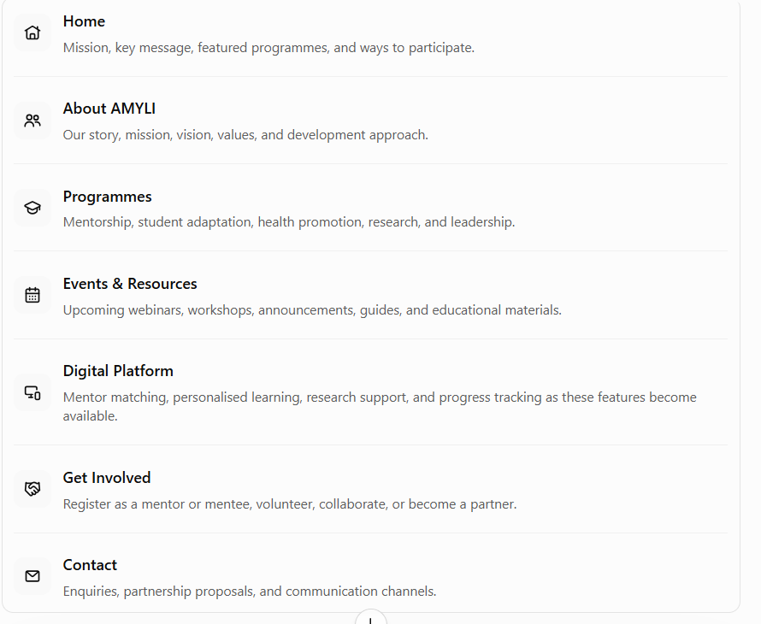

For vk webcommunity
Home, about amyli, programmes, events , get involved

